Maps are not Collections, but that doesn’t mean they’re not worth using! Being the primary Java family that supports key value pairs carves out a niche. Maps are one of the first things I think of when I need to keep a counter for a list of values. Consider this common entry level interview coding question:
“Given an Array, find the values that only appear once”
Example Array: {2, 4, 6, 4, 2, 457, -5}
Example Output: [6, 457, -5]
How would we use a Map to solve this?
High Level Overview
(Try this on your own before looking at the solution below)
--------------------------------------------------------------------------
● Instantiate a new empty Map with an Integer key and Integer value.
● Loop through the Array. For each iteration:

o If the value of the current Array index doesn’t exist as one of the Map’s keys, add it. Set the value to 1 since this is the first occurrence of the key.

o If the value of the current Array index does exist as one of the Map’s keys, increase that key’s value by 1.
● Now, you have a Map that has a key for each unique value in the Array, and a value that indicates how many times each value occurs.

● Instantiate a new empty List of Integers. This will hold our result.

● Loop through the Map’s keys. For each iteration:
o If the value of the current Key is 1, add it to the List. This is how we know that the Key only appears once in the Array.

● Return or print the List! (Depending on if you did this in a custom method, or directly in main)

Example Solution - Don’t look at this til you’re done or stumped!
This follows the steps outlined above, with a custom method that takes in the Array
---------------------------------------------------------------------------------------------------------
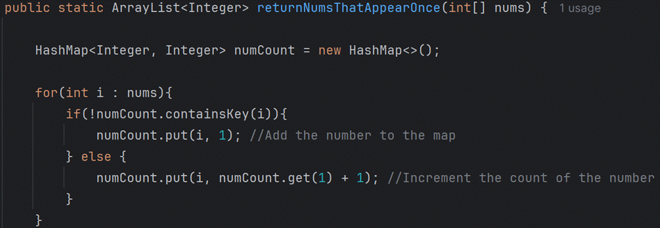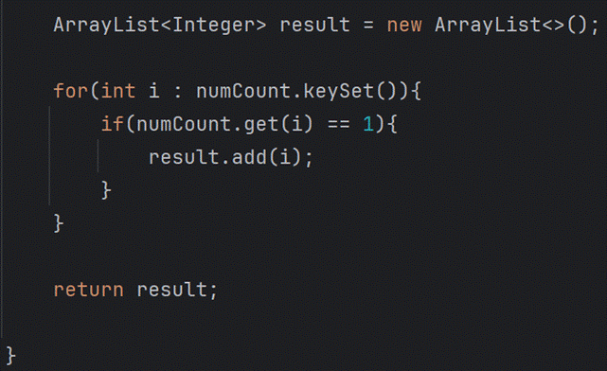

(This is all one method, just chopped in half for readability)

